Connect to docker from jenkins. Copy war file to docker host under home path
Docker user name: dockeradmin
Passwd: dockeradmin
Home path of dockeradmin user.
/home/dockeradmin
Install plug in: send artifacts over ssh
Gotomangejenkinsconfigure system ssh serverfill like below.
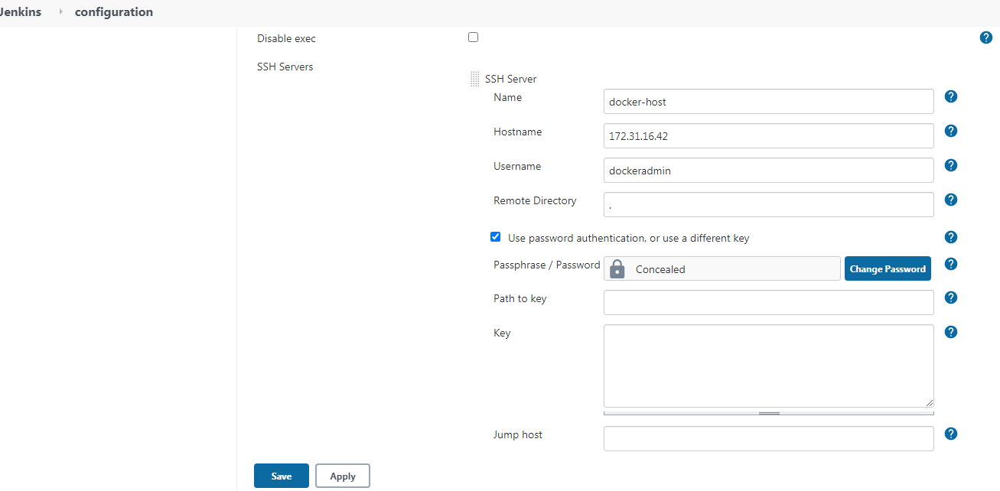
To generate pipeline syntax.
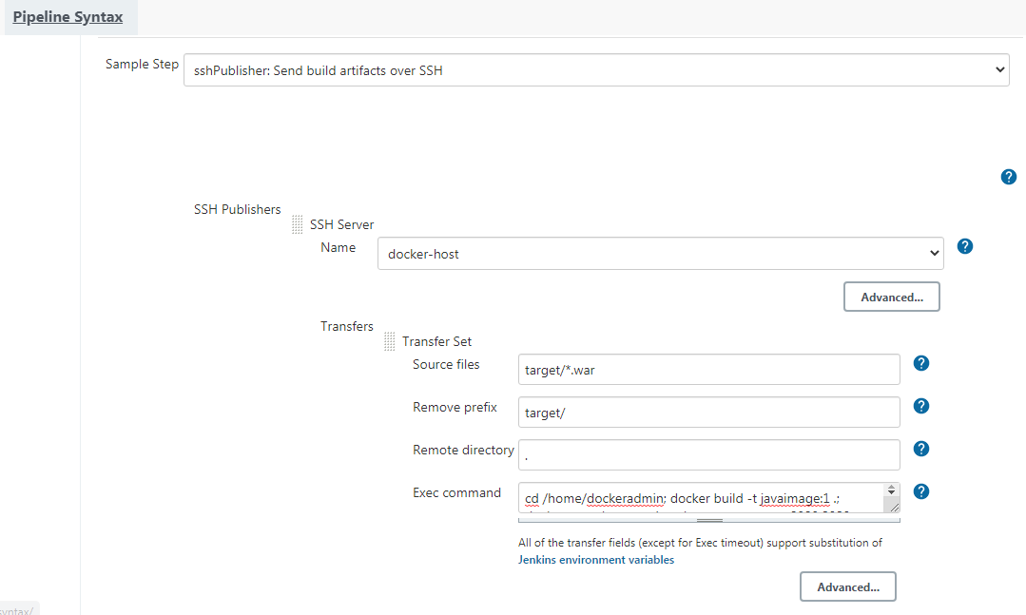
Remote directory means: directory on docker host. . means home directory or current directory

Sudo su – execute
Hostname docker-host execute
Sudo su - execute

//Copy the War file from Jenkins to docker host ,from docker host to docker container
Publish over ssh plugin

//to add users on linux mechine
Adduser dockername
Passwd dockeradmin
//go to particular user
Sudo su - ec2-user
Sudo su - dockeradmin
//adding dockeradmin user to the docker group
Usermod –aG docker dockeradmin

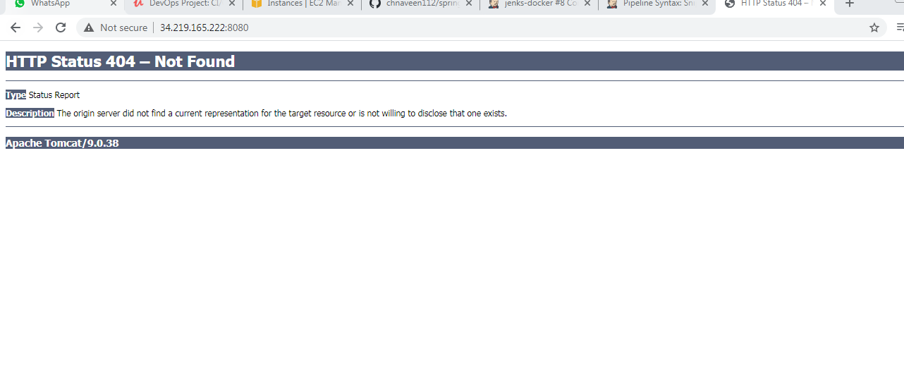o/p shows like this goto container
docker exec -it 3460b24f5181 bash
ls
cp -r webapps.dist/* webapps/

//To check users added to the docker group or not
Cat /etc/group
//To enable password based authentication yes
Vi /etc/ssh/sshd_config
Service sshd reload
Su – dockeradmin go to user:dockeradmin

To connect from one server to another here ansible to docker server
Generate keys on ansible aserver. Ssh-keygen
It generates in .ssh
To see . ls –la
Ssh-copy-id ansadmin@172.31.16.42 ==exec this command on ansadmin server :it takes you to ansible server to docker server.
Ansadmin user anme on docker host
172.31.16.42 private ip of docekr host .

Connect to ansible from Jenkins:
1.launch ec2 instance named: ansible server
2. then goto root user.
3. install ansible
4.then create user name: ansadmin add passwd: ansadmin
5.add this user to sudos file.
visudo
shift+G --end of the file ,click o insert mode. type: ansadmin ALL=(ALL) NOPASSWD: ALL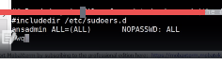
SO THAT IT WONT ASK FOR THE PASSWD WENEVER USE ROOT.
WQ:
6. INSTALL DOCKER
7. SERVICE DOCKER START
8.add ansadmin user to docker group
Usermod –a –G docker ansadmin
9.enable password based authentication
Vi /etc/ssh/sshd_config
10.reload : service sshd reload
11.su - ansadmin (switching to ansadmin user.)
12.generate keys
Ssh-keygen
13. login to docker host
A. create user ansadmin ,passwd :ansadmin
b.enable passwd authentication yes
14.. Goto ansible server: su - ansadmin
the copy the generated public key from ansible to docker server.
Ssh-copy-id ansadmin@privt_ip_of_dockerhost
15. ssh ansadmin@privt_ip_of_dockerhost it connect to docker host.

Dockerfile.
FROM tomcat:8
MAINTAINER CH NAVEEN
COPY ./springmvc.war /usr/local/tomcat/webapps

Ansible-playbook.yml:
---
- hosts: all
become: true
tasks:
- name: build docker image
command: docker build -t myapp .
args:
chdir: /opt/docker

- name: run docker container
command: docker run --name javacontainer -d -p 8080:8080 myapp

inthis if we build, container name is created, if we build again shows container name already exis error.
To overcome this.

---
- hosts: all
become: true
tasks:
- name: stop the container
command: docker ps javacontainer
ignore_errors: yes

- name: remove the container
command: docker rm -f javacontainer
ignore_errors: yes

- name: remove the image
command: docker rmi myapp
ignore_errors: yes

- name: build docker image
command: docker build -t myapp .
args:
chdir: /opt/docker
- name: run docker container
command: docker run --name javacontainer -d -p 8080:8080 myapp

